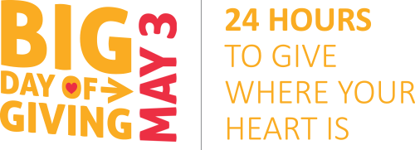
What is Big Day of Giving?
Big Day of Giving is about coming together to celebrate the impact of non-profits on their communities! Over a 24 hour period from midnight to midnight on May 3rd, JFK Marching Band & Color Guard will join with over 500 non-profits in the region to raise funds that benefit and enrich the community.
What will your gift provide?
For as little as an online donation of $25, your contribution to the JFK Marching Band & Color Guard will help foster the love of music education, teamwork and independence through leadership, responsibility, dedication and community service.
MARK YOUR CALENDARS!
BIG DAY OF GIVING!
May 3, 2016
YOU can participate on Big Day of Giving by supporting the JFK Marching Band & Color Guard and your other favorite non-profits. Join us on May 3rd for this historical event in our region!
JOIN US BY:
- Making an online tax-deductible contribution to the JFK Marching Band & Color Guard on May 3, 2016.
Here is the direct link to our Giving Edge page:
https://givingedge.guidestar.org/nonprofit.aspx?orgId=1132249

- Making a cash or check donation before May 3, 2016, by listing your donors on the attached pledge sheet, and delivering it with the enclosed donations to Mr. Hammond.

- Spreading the word!
Tell your friends, post on Facebook, and like our page at
https://www.facebook.com/John-F-Kennedy-High-School-Marching-Band-and-Color-Guard-154639054587045/

