 | 2017 - 2018 JFK Marching Band & Color Guard  Hooded Sweatshirt Order Form | 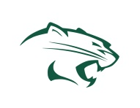

ORDERS DUE – September 30th
Student Name |  | Grade  ☐9th ☐ 10th ☐11th ☐12th
Student email | Student cell phone | Student home phone

Students who have paid the full amount due for Fair Share
by September 30 are eligible to receive a FREE sweatshirt.
If you have paid in full, write “0” in total due column.
All sweatshirts are $40 and come embroidered with one name of your choice (first or last name).
Subtract $5 if you do not want a name embroidered on the sweatshirt.
Adult Size (unisex) | Embroidered name (please print legibly) | Quantity | Total
S |  |  | $
M |  |  | $
L |  |  | $
XL |  |  | $
2XL |  |  | $
GRAND TOTAL |  |  | $
Please make checks payable to:
“JFK Band and Color Guard”
Band use only: | AMT REC’D | CASH | CHECK #

