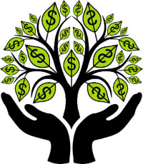

February 5, 2018
Dear JFK Band Members and Families,

The JFK Marching Band Parent Club, as part of our fundraising efforts for the band’s upcoming trip to Washington D.C., has put together a crowdfunding campaign using Crowd Rise.

What is Crowdfunding?
Crowdfunding is the practice of funding a project or venture by raising many small amounts of money from a large number of people (family, friends, work associates, etc.) via the Internet.

Why Crowdfunding?
We have a lot of funds to raise for the D.C. trip and want to use every avenue available to meet the band’s goal of $250,000. By reaching out to the broader community this way, we hope to solicit additional dollars to reach our goal beyond the fundraisers we have already planned.

What’s Next?
To ensure we reach as many people as possible, we would like you to the following easy steps to join our fundraising team. Simply click on the link below and select FUNDRAISE FOR THIS CAMPAIGN. From there you can create an account, share the fundraising link with friends and family and provide personal updates on the campaign explaining why the funds are important, and what they and the trip mean to you personally. The platform also allows you to link your Facebook and Twitter accounts to reach even more people in your network.

Link: https://www.crowdrise.com/jfk-marching-band-pathway-to-dc

Please feel free to reach out to me at secretary@jfkennedyband.com should you have any questions on the campaign or the CrowdRise platform. And remember, together anything is possible.

Thank you!
Cindy Kazee, Secretary

